TCODE - BP - Custom Tab Addition at Company code level
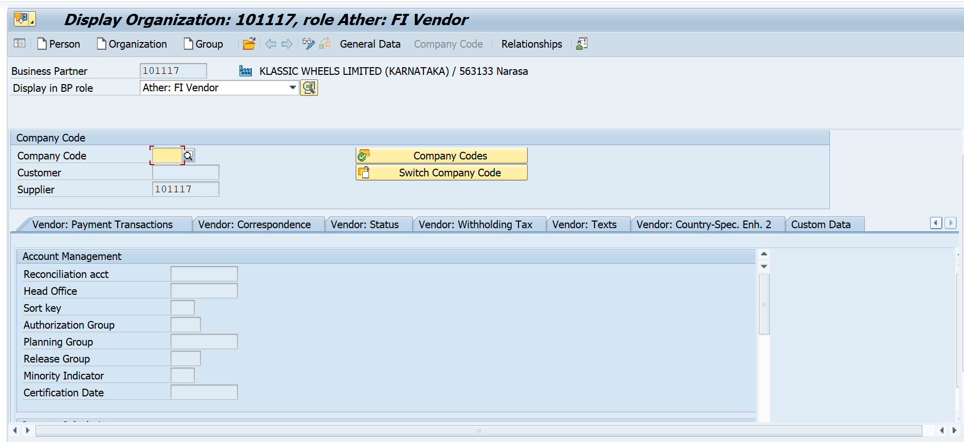
Step 1: Create the Screen & Function Group
- Go to transaction SE80. Select Function Group, enter a name (e.g., ZMM_BP_VCC_CUSTOM_TAB), and press Enter to create it.
- Right-click the Function Group and choose Create -> Screen.
- Enter Screen Number 9002.
- In the Screen Attributes, set the Screen Type to Sub screen.
- Click Layout to open the Screen Painter.
- Drag and drop your fields from table (ex: -LFB1) onto the screen layout.
- Activate the screen and the entire Function Group.
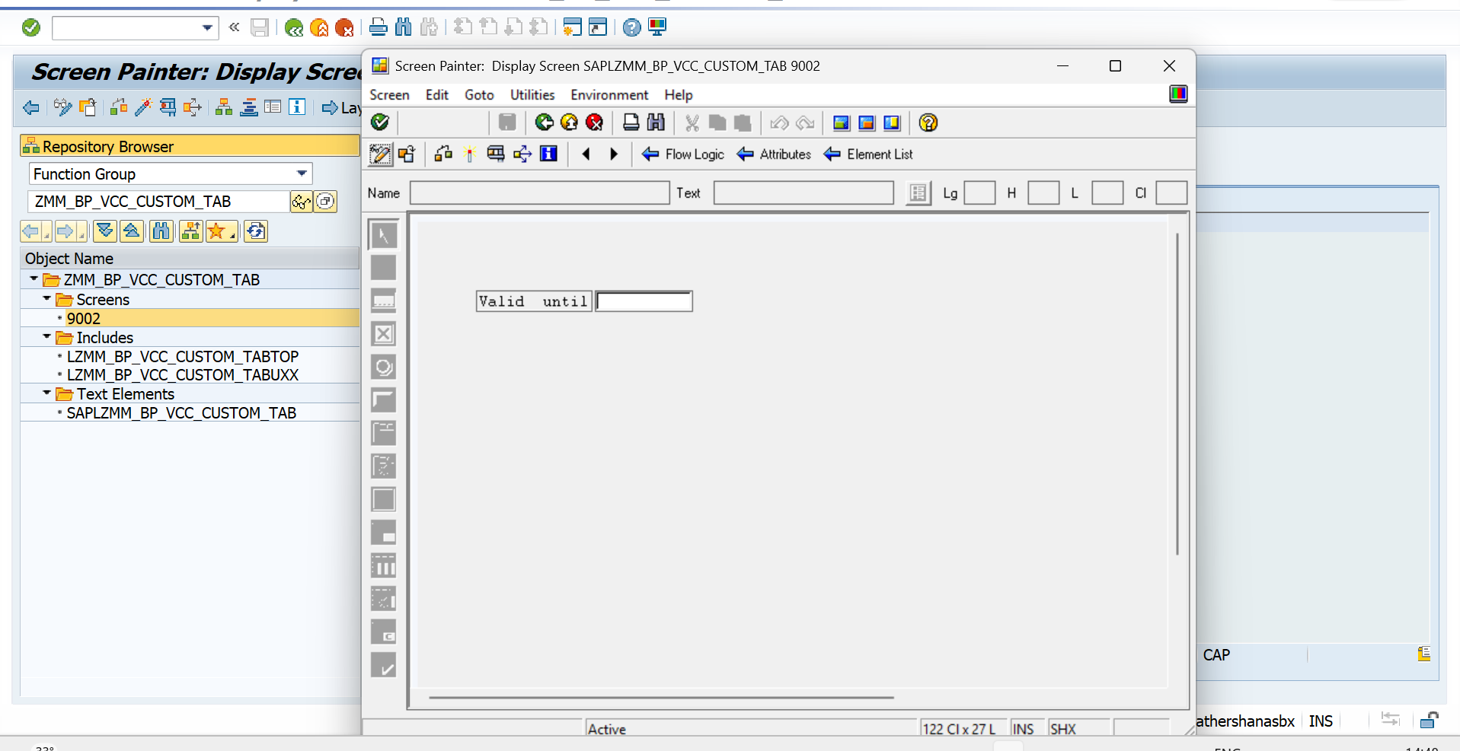
Step 2: Create a Custom Application (BUS1)
- Go to BUS1 (Applications).
- Click New Entries.
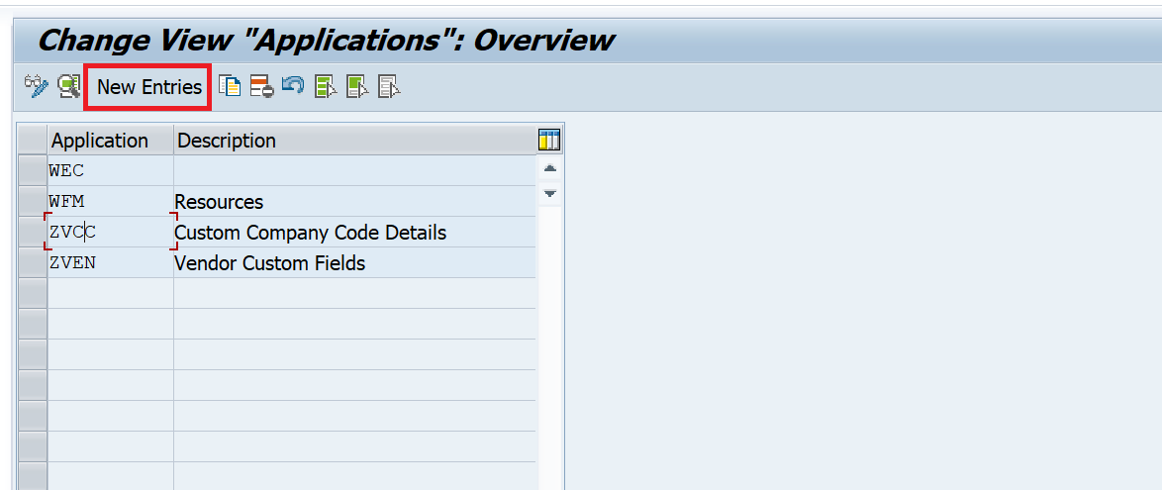
- Application: ZVCC (or any 3-letter Z identifier).
- Description: Custom Company Code Details
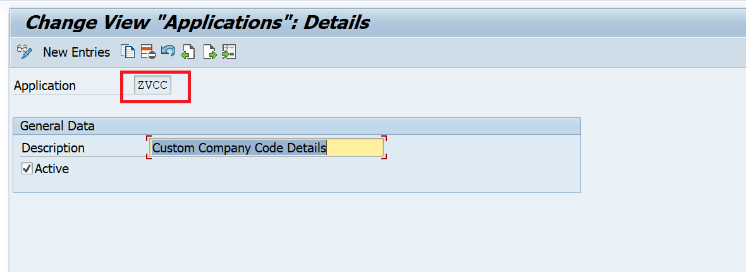
- Save the data.
Step 3: Create a Data Set (BUS23)
- Go to BUS23 (Data Sets).
- Click New Entries.
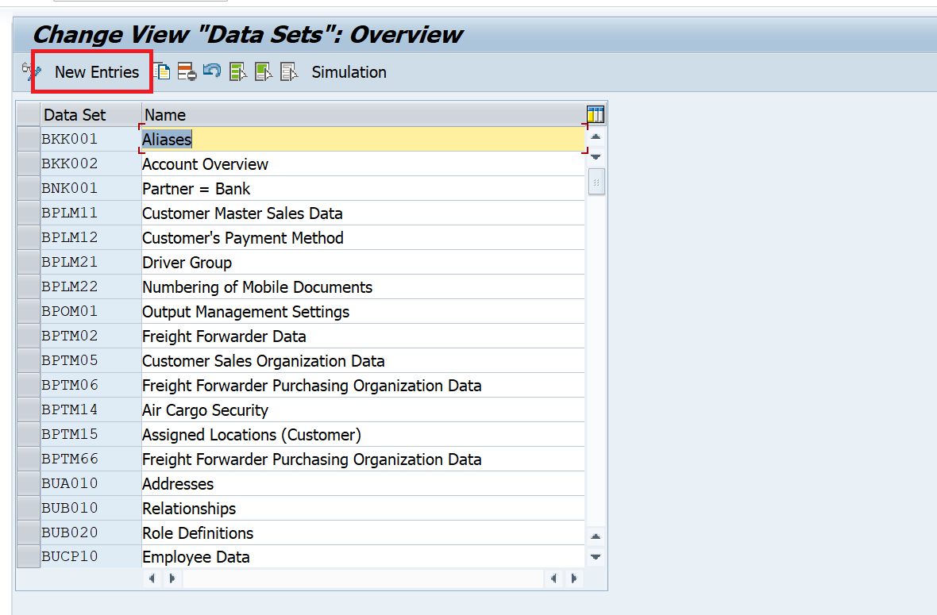
- Data Set: ZVCC01
- Description: Vendor Company Code Custom Fields
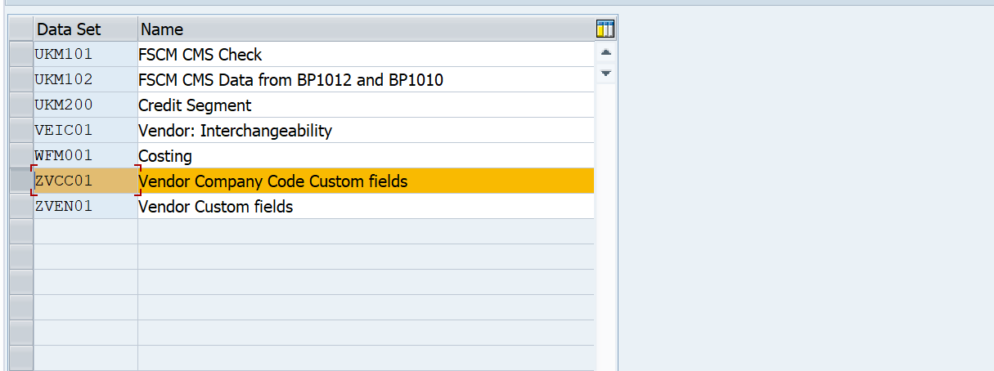
- Save the data.
Step 4: Create a Field Group (BUS2)
- Go to BUS2 (Field Groups).
- Click New Entries.
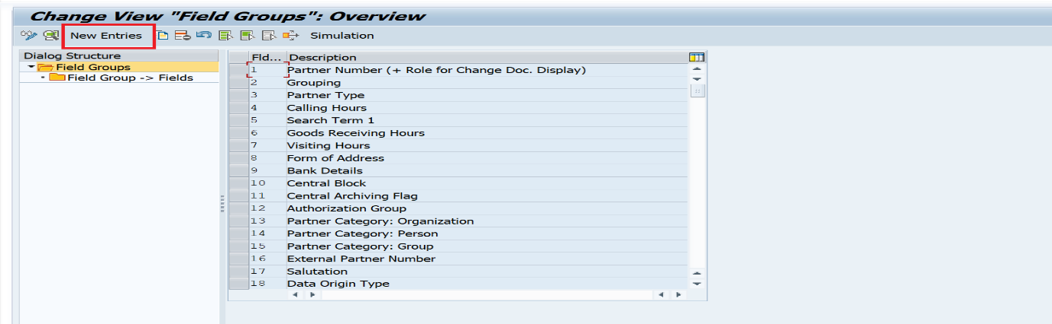
- Create Group 602(With Any number we can create) named Vendor Company Code Custom Fields
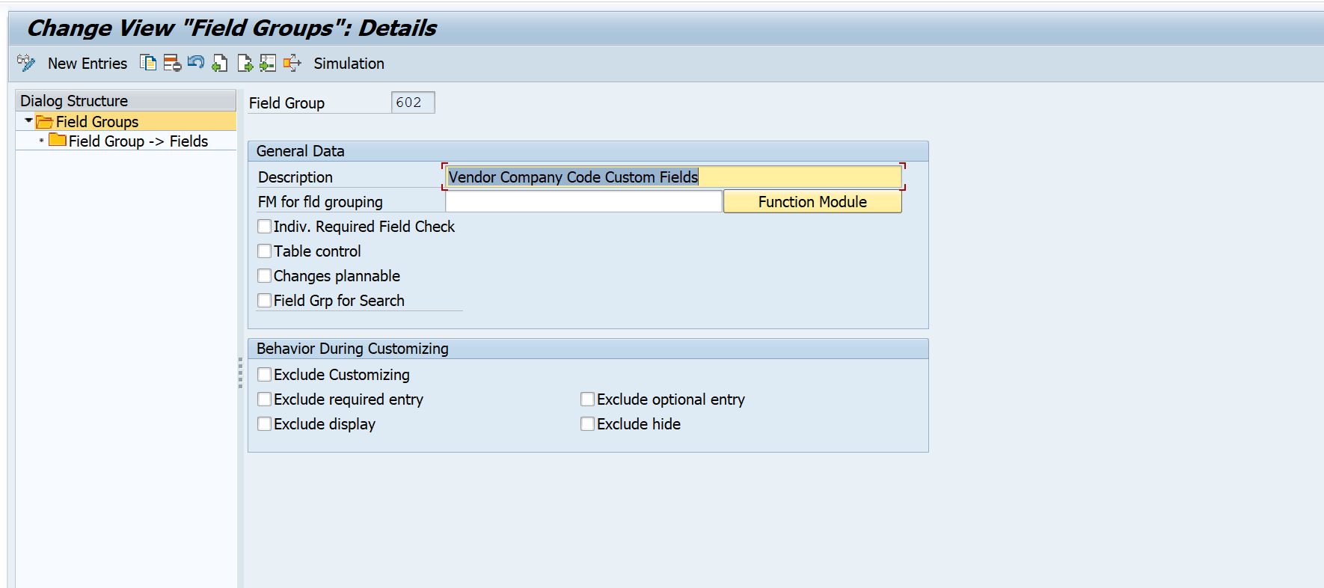
- Select Group 602, double-click Field Group -> Fields, and insert your specific table fields:
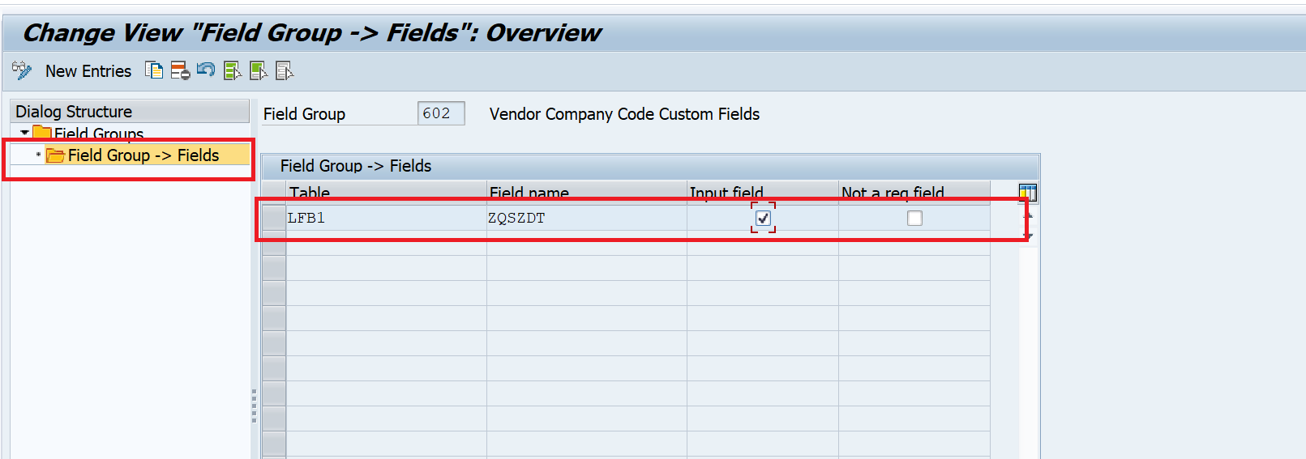
Example:
  - Table: LFB1 | Field: ZQSZDT
- Save the data.
Step 5: Create the View (BUS3)
- Go to BUS3 (Views). Click New Entries.
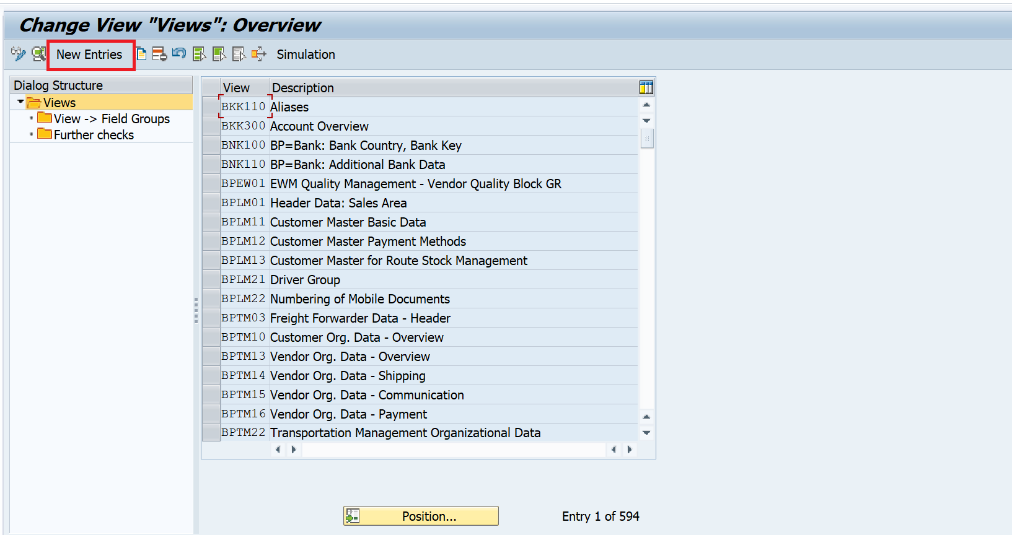
Once we click on New Entries, a new screen will come. We need to fill those required fields as mentioned in below steps
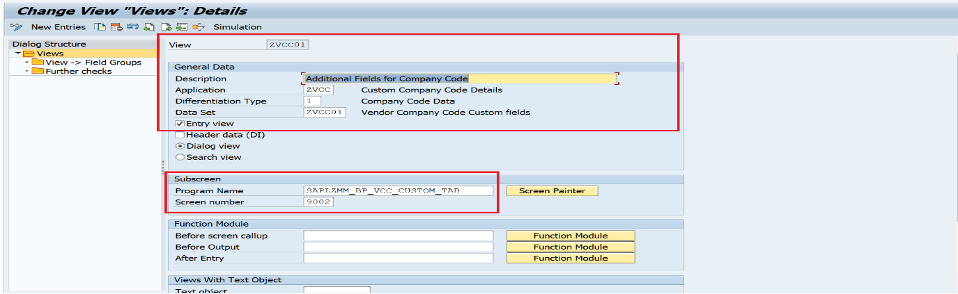
- View: ZVCC01 | Title: Additional Fields for Company Code
- Application: ZVCC (Created in Step 2)
- Differentiation Type: 1 (Need to choose from F4 Help-Based on Tab where do we want to display
In this example we are adding the custom tab at Company code level)
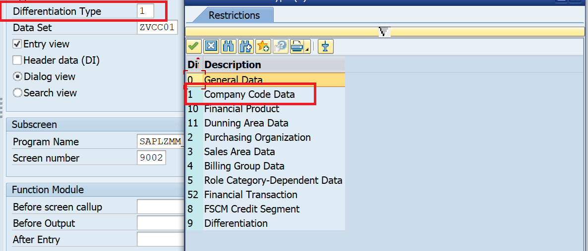
- Data Set: ZVCC01 (Created in Step 3)
- Program Name: Enter your function group main program (e.g., SAPLZMM_BP_VCC_CUSTOM_TAB).
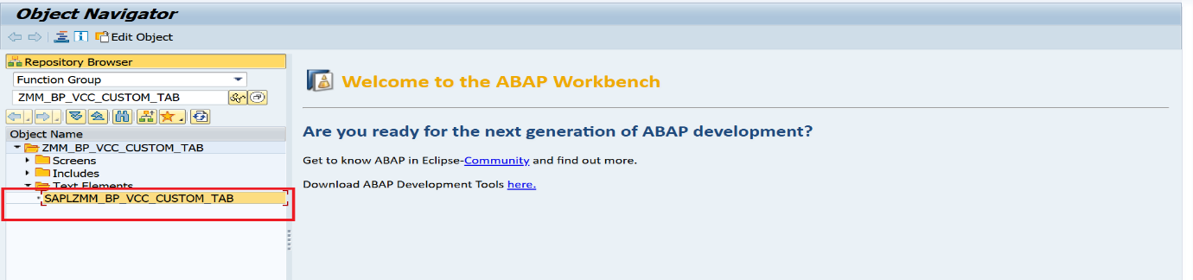
- Screen Number: 9002, Save and Go Back to Main Screen.
- Select ZVCC01, double-click View -> Field Groups, and add Field Group 602(Created in Step 4). Save your settings.
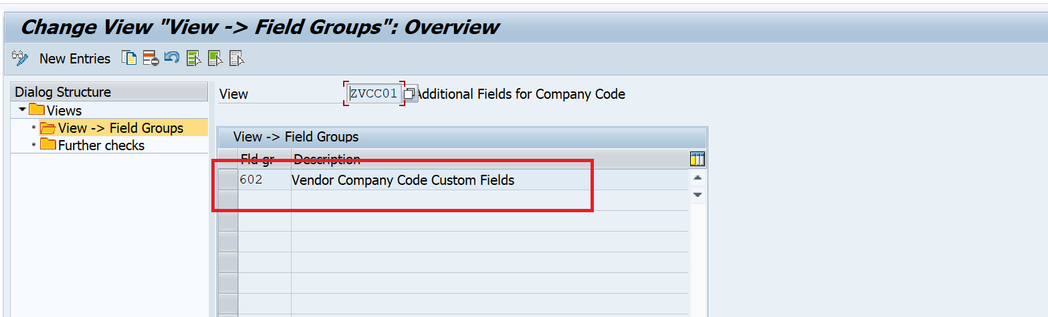
Step 6: Create the Section (BUS4)
- Go to BUS4 (Sections). Click New Entries.
- Section: ZVCC01 | Description: Vendor Company Code data | Title: Excess Data (This is the screen name that will appear on our custom screen 9002.)
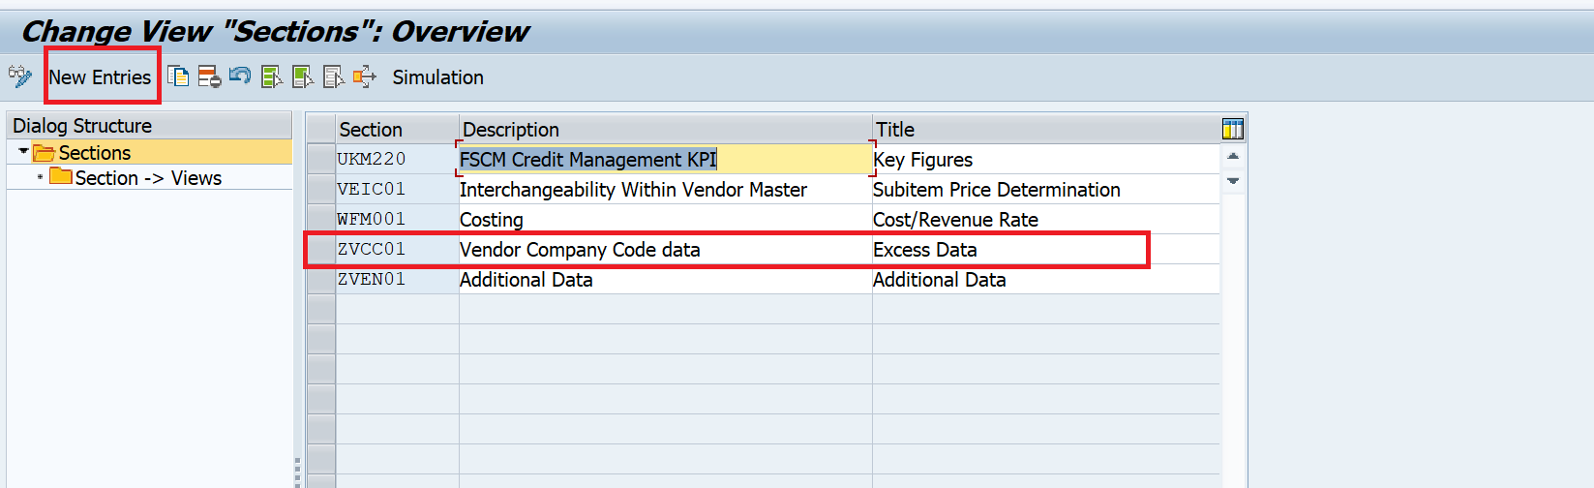
- Go Back to Main Screen and Select ZVCC01, double-click Section -> Views, and add your View ZVCC01(Created in Step 5).
- Item: 1 (We can give any number) | Save your settings.
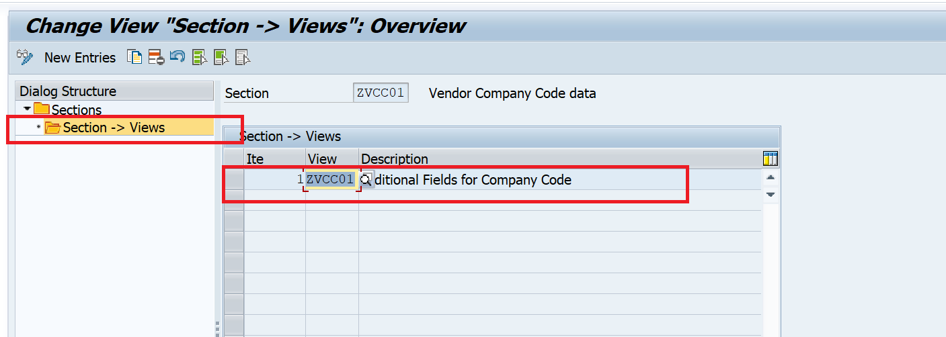
Step 7: Create the Screen/Tab Container (BUS5)
- Go to BUS5 (Screens). Click New Entries.
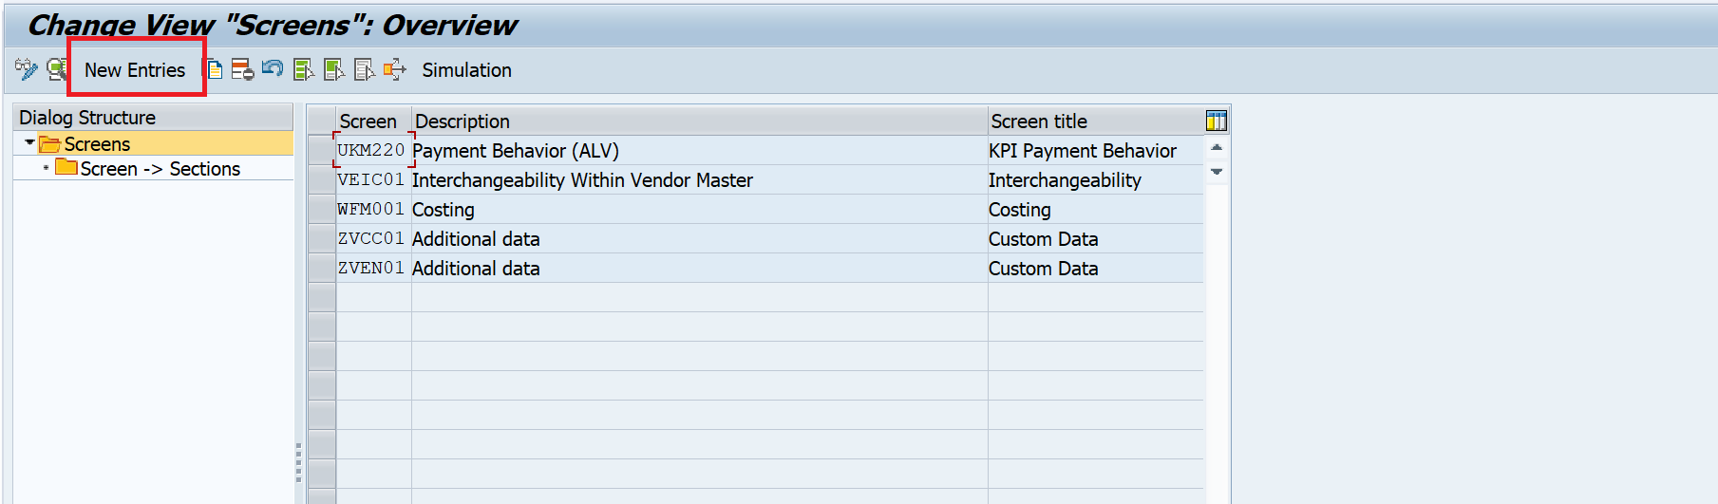

- Screen: ZVCC01 | Description: Additional Data | Screen Title: Custom Data (This is the tab name that will appear in the standard transaction.)
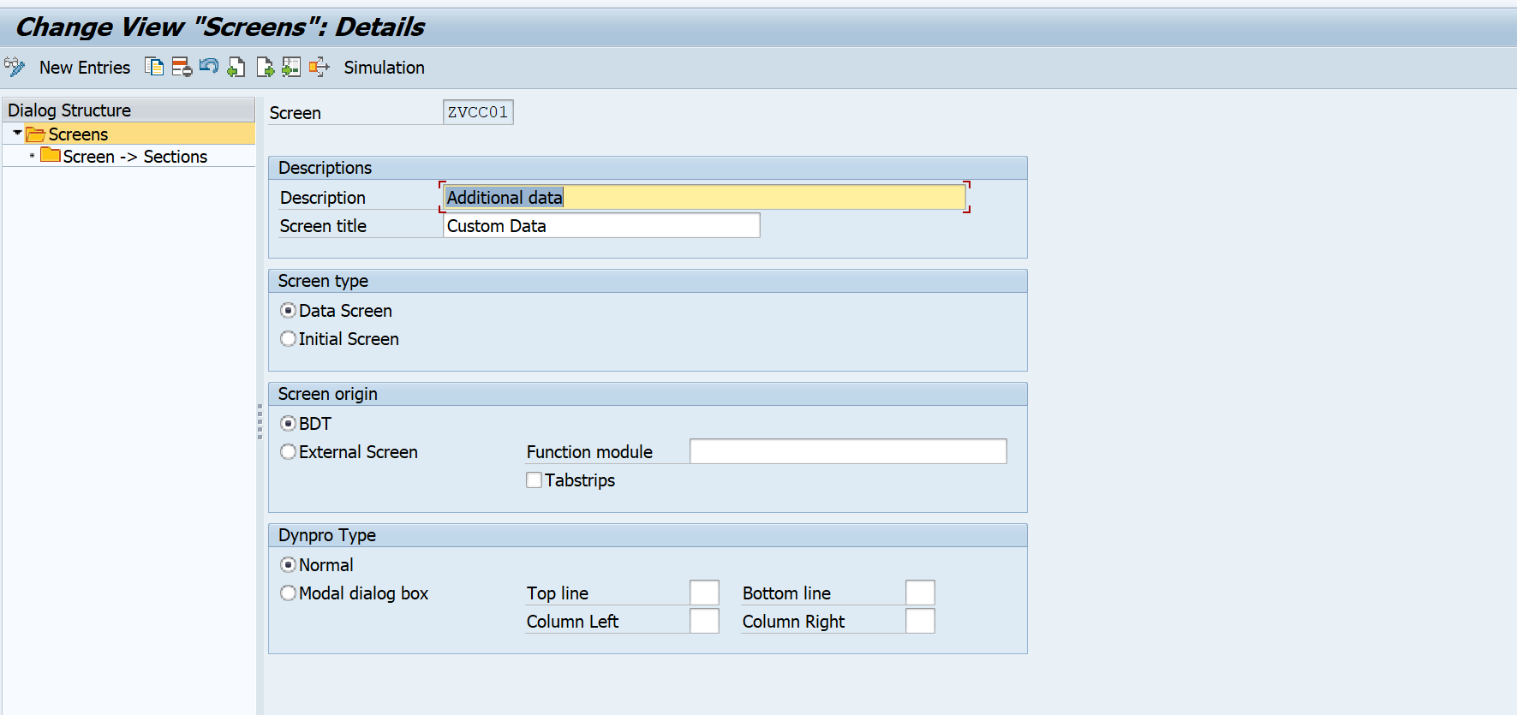
- Screen Type: Data Screen, Save and Go Back to Main Screen
- Select ZVCC01, double-click Screen -> Sections, and map your section:
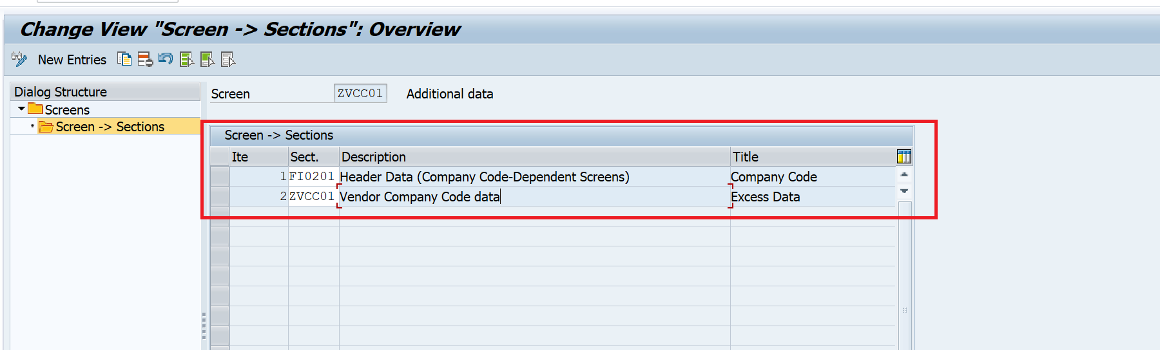
4a. Here, we have selected the Standard Section FI0201.
We can find this Section by following these below steps.
- Go to transaction BP. (On which Transaction we are working)
- Navigate to the Company Code data screen. (On which data Screen We are adding the Tab.)
- Type BDT_ANALYZER in the command bar and hit Enter.
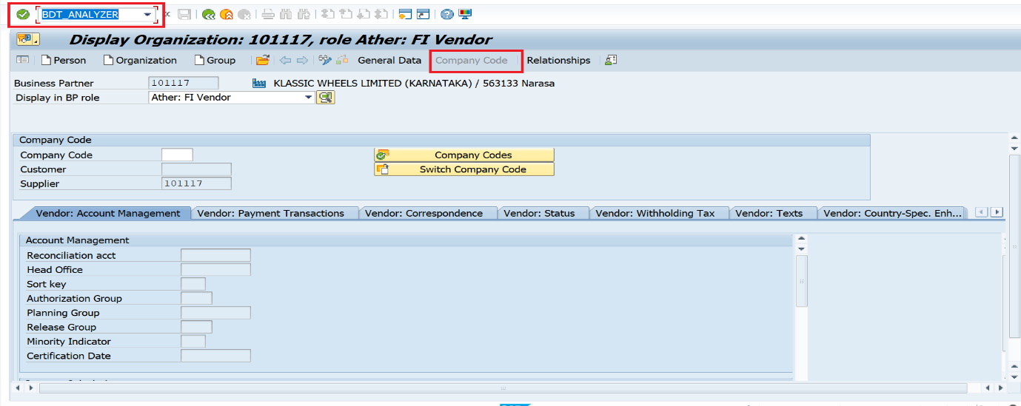
4. Once we click on Enter, One Popup will come.
5. Expand the popup tree to view the active Screens and Sections.
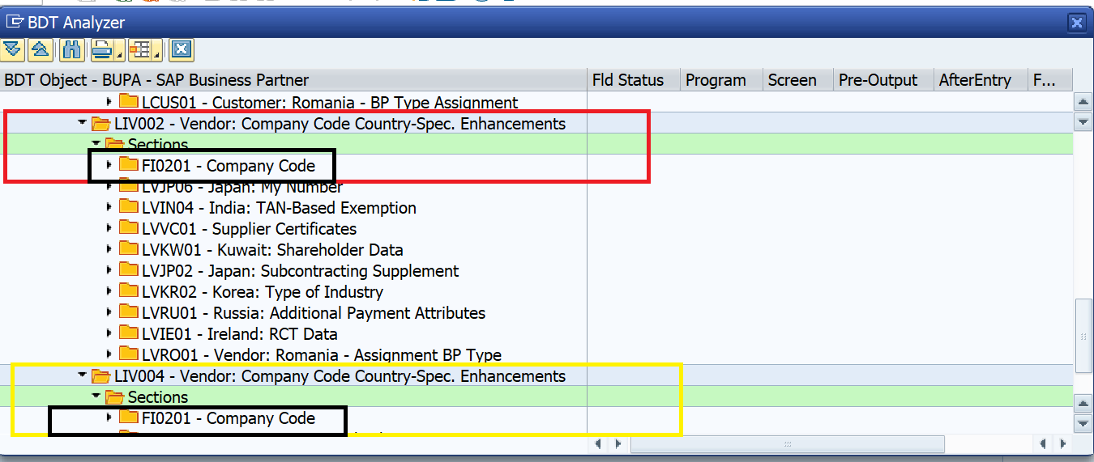
6. Locate the Company Code tabs to find the sections. (Standard Tabs From Company Code)
7. The standard Company Code layout uses sections FI0201.
8. The new custom tab will be added to this same section (FI0201) in BUPT
configuration.
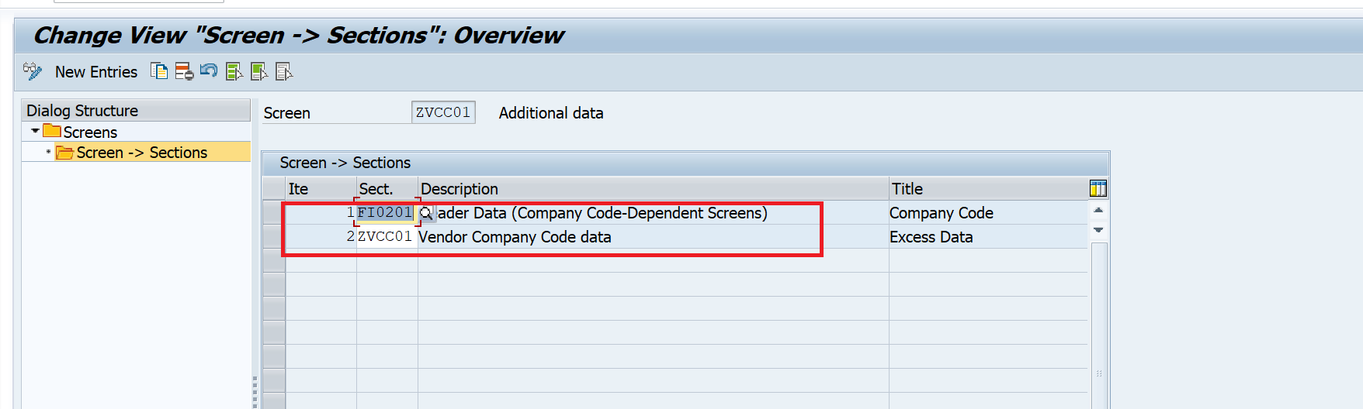
4b. custom Section ZVCC01 for mapping to standard (Created in step 6).
Save your settings.
Step 8: Integrate into the Company Code Screen Sequence (BUS6)
- Go to BUS6 (Screen Sequences).
- Locate the standard screen sequence for Company Code operations: FS0001(Find the exact sequence based on the target data screen. Since our requirement is to add a tab at the Company Code level, we can identify the correct sequence using its Description. As shown in the screenshot below, FS0001 has the description "Company Code - Dependent Data".)
- Select FS0001 and double-click Screen Sequence -> Screens.
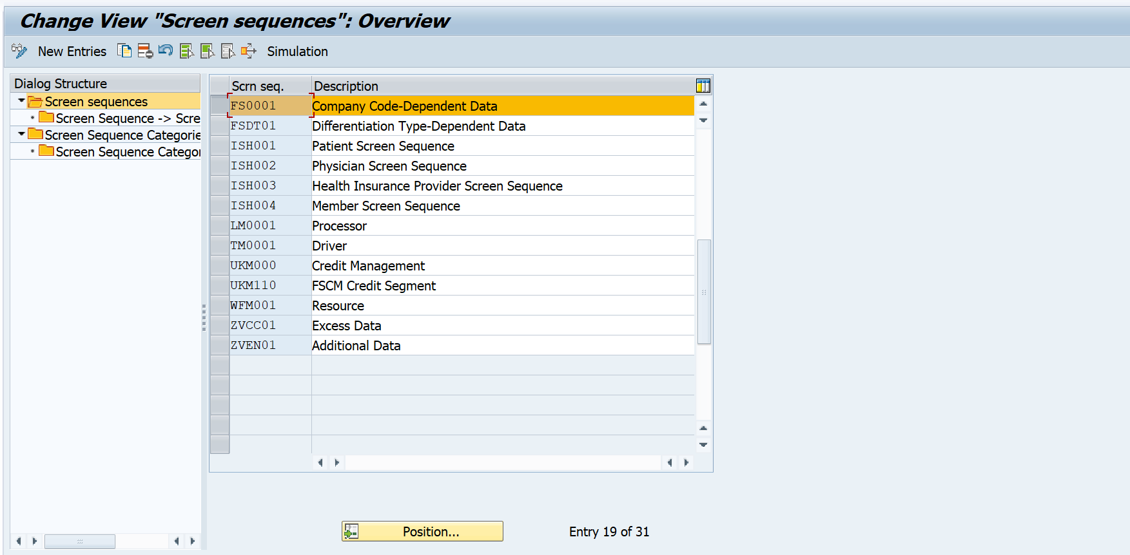
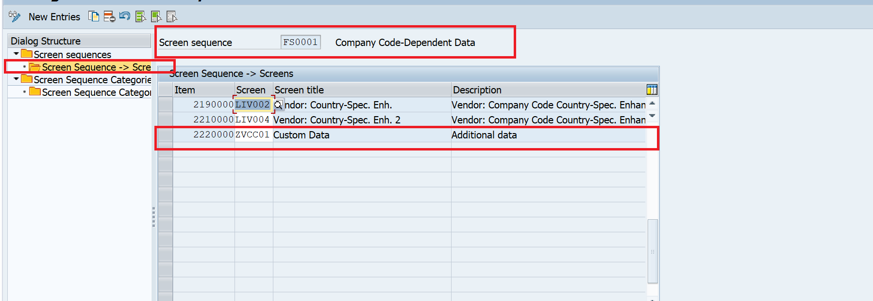
- Click New Entries and append your new tab screen container:
  - Item: 2220000 (or the next available numerical slot at the bottom of the list).
  - Screen: ZVCC01(Created in Step 7)
  - Screen Title: Custom Data.
- Save your settings.
Tab Sequence
6. Go Back to Main Screen -->Click New Entries
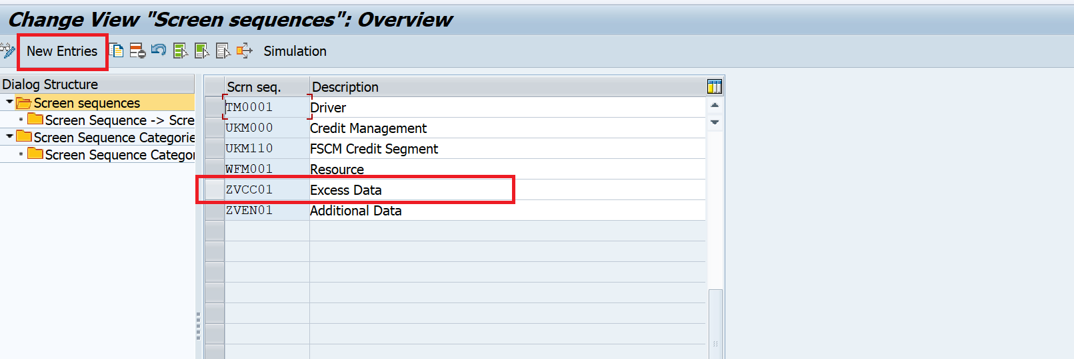
8. Create Custom Screen Sequence ZVCC01 named Excess Data
7. Select ZVCC01 and double-click Screen Sequence -> Screens
8. Click New Entries and append your new tab screen container:
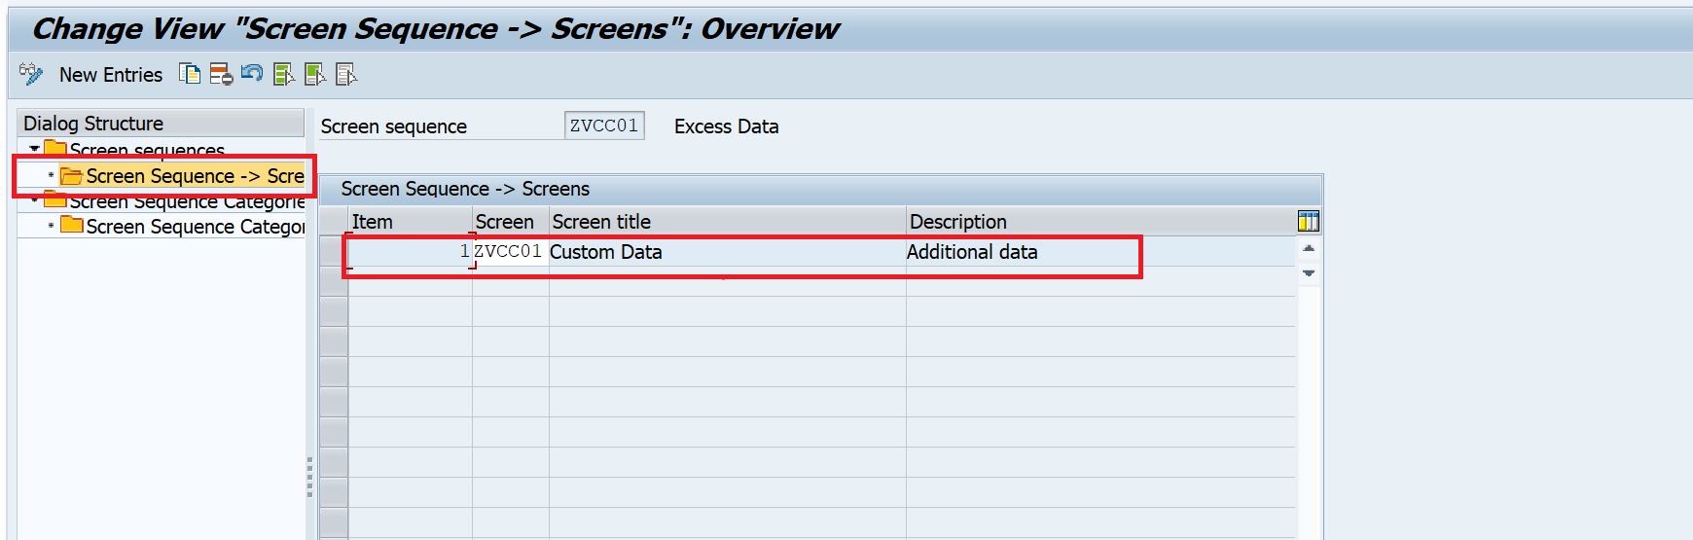
9. Save your settings.
10. Click on Screen Sequence Categories. Click New Entries
11.Create Screen sequence Category ZVCC01 named Excess Data
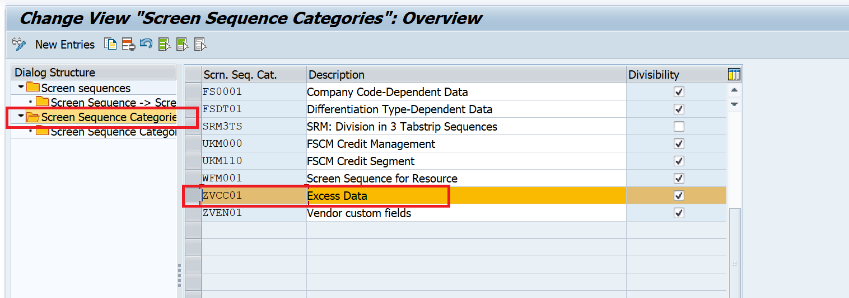
12. Select ZVCC01 and double-click Screen Sequence Category -->Screen Sequence
13.Click New entries and create Screen Sequence Category-->Screen Sequence.
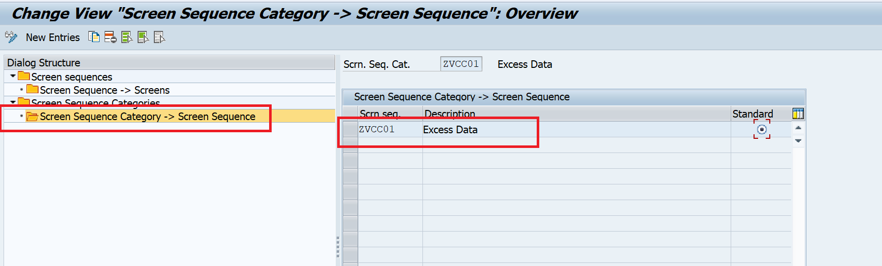
14.Save the settings.
Once we implement all these steps, we can see the Custom Tab.
